H.T No
Regulations:
A20

Sreenidhi Institute of Science and Technology
(An Autonomous Institution)
Code No: 8AC48 Date: 08-Feb-2024 (FN)

B.Tech II-Year I- Semester External Examination, Jan/Feb -2024 (Supplementary)
ELEMENTS OF ELECTRICAL AND ELECTRONICS ENGINEERING (CS, AIML, DS and IOT)

Time: 3 Hours Max.Marks:70

Note: a) No additional answer sheets will be provided.
b) All sub-parts of a question must be answered at one place only, otherwise it will not be valued.
c) Missing data can be assumed suitably.

Bloom's Cognitive Levels of Learning (BCLL)

Remember | L1 | Apply | L3 | Evaluate | L5
Understand | L2 | Analyze | L4 | Create | L6

Part - A Max.Marks:20
Answer all QUESTIONS

 |  | BCLL | CO(s) | Marks
1 | Distinguish among Independent and Dependent Sources | L2 | CO1 | [2M]
2 | Define RMS value and Average Value? | L1 | CO2 | [2M]
3 | Sketch the 3-phase slip ring Induction motor? | L2 | CO3 | [2M]
4 | Discuss on Intrinsic and Extrinsic semiconductors? | L2 | CO4 | [2M]
5 | Draw the circuit symbols of PNP and NPN transistor | L2 | CO5 | [2M]
6 | State De-Morgan’s theorem? | L1 | CO6 | [2M]
7 | State Superposition theorem? | L1 | CO1 | [2M]
8 | List out the properties of ideal PN junction diode? | L2 | CO4 | [2M]
9 | Draw the symbol of PNP and NPN transistor | L2 | CO5 | [2M]
10 | Write the function of ‘j’ operator? | L2 | CO2 | [2M]
Part – B Max.Marks:50
ANSWER ANY FIVE QUESTIONS. EACH QUESTION CARRIES 10 MARKS.

 |  |  | BCLL | CO(s) | Marks
11. | a) | Obtain the node voltages Vx and Vy using nodal analysis for circuit shown below,  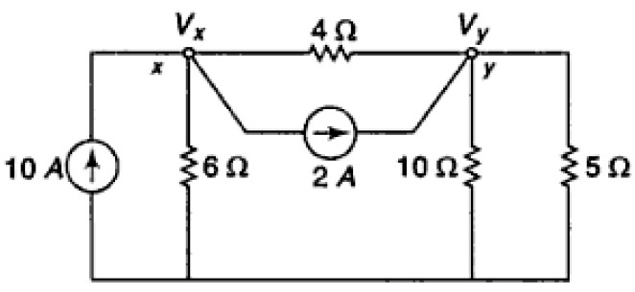 | L3 | CO1 | [5M]
 | b) | Explain the working principle and operation of DC Generator? | L2 | CO1 | [5M]
12. | a) | A series RL circuit having a resistance of 4Ω and inductance reactance 3Ω is connected to 100V, 50Hz, single phase supply. Find the Impedance, current, and power factor. | L3 | CO2 | [5M]
 | b) | Find the form factor for the Current wave form shown below.  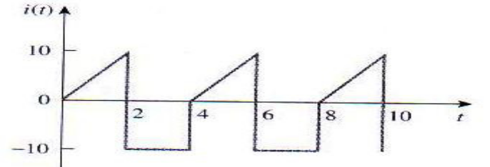 | L3 | CO2 | [5M]
13. | a) | Explain the working principle and operation of 3- Phase Induction motor? | L2 | CO3 | [5M]
 | b) | Explain the operation of PMMI instrument? | L2 | CO3 | [5M]
14. | a) | Explain the operation of PN Junction Diode, Also draw its VI characteristics | L2 | CO4 | [5M]
 | b) | Illustrate the operation of bridge type rectifier with filter? | L3 | CO4 | [5M]
15. | a) | Explain the operation of CC Configuration of BJT and its input and output characteristics briefly. | L2 | CO5 | [5M]
 | b) | Explain the construction and operation of PNP transistor? | L2 | CO5 | [5M]
16. | a) | Determine the Boolean expression for the output of the system shown in figure.  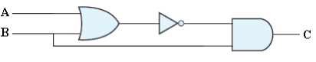 | L3 | CO6 | [5M]
 | b) | Interpret the truth table of NAND, NOR and EX- OR gate | L2 | CO6 | [5M]
17. | a) | A shunt generator delivers 450A at 230V and the resistance of shunt field and armature are 50Ω  and 30Ω respectively. Calculate the generated emf. | L2 | CO1 | [4M]
 | b) | What is balanced three phase circuit? Write the relation between line, phase voltage and Current for three phase balanced Delta Connection? | L2 | CO2 | [3M]
 | c) | What is Rotating Magnetic Field? | L1 | CO3 | [3M]
18. | a) | Write a short notes on clippers and also mention its applications | L2 | CO4 | [4M]
 | b) | Discuss the operation of MOSFET? | L2 | CO5 | [3M]
 | c) | Outline the concept of duality in Boolean algebra. | L2 | CO6 | [3M]
-- 00 -- 00 –

